Realistic Fiction – Character Cards

Dear Parents, August 20, 2013

The book report for September will be a **realistic-fiction** based chapter book that is within their reading range and is at least 80 pages. Realistic Fiction, although untrue, could actually happen.  Some events, people, and places may even be real. Some examples of realistic fiction are such are Diary of a Wimpy Kid, Shiloh, Hatchet, Junnie B. Jones, How to Eat Fried Worms, Holes, Dork Diary and hundreds more. If you have any question if a book counts, go to Scholastic.com and click teacher book wizard type in the book that your child wants to read and it will tell you which genre it is.

Most Parents, I think, are very familiar with Yogi man cards, baseball cards, football cards etc. Your students will be making **character cards** for the characters within their books. They must make a minimum of four cards. On the front side of the card it should have a picture of the character. I don’t care if this is drawn or printed off of the internet. On the back of the card must contain facts about this person from the story. For example what they look like, what their role in the story is, nicknames, hobbies they may have, and anything that lets us get to know the characters. These book reports will be due **September 30th**, which will give your student over a month to get a book chosen and read. Attached is a rubric of what is expected of you child as they create their character cards. We will discuss what a character cards entails in class so your student knows what is expected.

I hope that your child is reading and enjoying every minute of it. Reading is so much fun and will open doors to adventures and mysteries unlike any other. It is also the best thing students can do to become successful in their school work. It is a privilege working with you, and thank you for all you do in behalf of your child.

Mr. Torrey

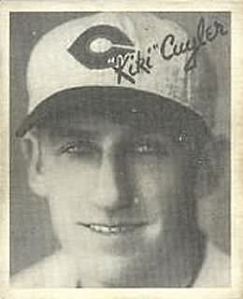

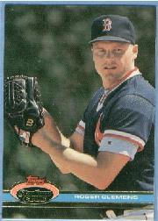

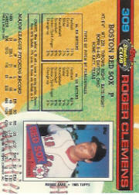

**Character Cards!**

Name:______________________

|  |  |  |
| --- | --- | --- |
| **Brief Summary**   * Tell us the book and author in your brief summary of your book. | Name/Book Title/Author | 10pts |
| **Character Card Directions**   * Does your card resemble a baseball card. Does it describe characters from your book! | On front of your card you need to draw a picture of your character.  On the back you need to add information such as a description of a character, age, role in the story, character traits, etc. | 20 pts |
| **Creativity**   * Is there a wow factor with your Character Cards you’ve made to represent your characters? | Time spent, Imagination, effort. | 30pts |
| **Oral Presentations**   * ***1 minutes describing your cards***. * Students will show their cards to the class and describe how the characters relate to the story. | (Oral Presentation)  1pt - Eye Contact  1pt – Loud and Clear  1pt – Standing not fidgety  1pt – Avoid “um”, like and “you know” | 40pts  TOTAL: |